**NarcoTech**

**Specifications**

**Alexa Physio Reminder Skill**

**Appointment Reminder System for O.P.S**

**Team Members Contact**

Tarika Birch (PRO) tarika.birch@mycavehill.uwi.edu

Dwayne Archer dwayne.archer@mycavehill.uwi.edu

Kai Hill kai.hill@mycavehill.uwi.edu

Aaron Grimes aaron.grimes@mycavehill.uwi.edu

Kelilah Mayers kelilah.mayers@mycavehill.uwi.edu

Contents

Introduction 3

Project Overview 3

Prototype 4

Requirements 4

User Requirements 4

Functional Requirements 4

Non-Functional Requirements 5

System Model 6

Data Flow Diagrams 6

A. Context Diagram 6

B. Level 1 Diagram 7

C. Level 2 Diagram 8

Data Definitions 9

System Architecture 10

System Components 10

Technology Stack 10

Constraints and Assumptions 11

Constraints 11

Assumptions 11

Prospective Feature Set 12

# Introduction

**Purpose of the Document**

The purpose of this document is to define the specifications and requirements for the development of an Alexa Skill, Physio Reminder, aimed at providing appointment reminders for patients undergoing physiotherapy sessions at Optimal Physiotherapy Services (O.P.S). The skills primary focus is the reduction of missed appointments, thereby improving the overall patient recovery process.

**Document Overview**

The document outlines the scope, functional and non-functional requirements, system architecture, testing procedures and other key aspects of the project. It provides a structured approach to the specification of the project’s requirements and criteria for its successful completion.

# Project Overview

**Project Description**

The scope of the project involves the development and implementation of an Alexa Skill designed to provide appointment reminders and information for physiotherapy sessions at Optimal Physiotherapy Services (O.P.S).

**Project Objectives**

The primary objective of this project is to provide Optimal Physiotherapy Services with a tool to aid their older clientele suffering with Repetitive Strain Injuries, reminding them about their upcoming physiotherapy appointments. This will be completed through the utilization of the Alexa Skills Kit. Through the implementation of this project we aim to:

* **Reduce Missed Physiotherapy Sessions:** The skill should reduce missed appointments by providing a platform to facilitate reminders about these upcoming appointments.
* **Improve Patient Recovery Times:** Through reducing the number of missed appointments, patients should no longer experience prolonged post-rehabilitative care.

# Prototype

A prototype of the system was created in a local development environment using Visual Studio Code in order to better understand the components that would be required for the system to be effective. This prototype was designed using JavaScript for functionality and JSON files for data storage. Some of the requirements outlined in this document were directly derived from the functions of the prototype while others were included based on the functionality the prototype lacks.

# Requirements

## User Requirements

1. The system will allow the user to enter their name and check their appointment information.
2. The Alexa Skill will provide the user with the ability to check the date, time and therapist associated with their upcoming appointments.
3. The system will allow the user to check the time of the appointment on a given date.
4. The system will allow the user to add a reminder for an appointment.
5. The system will allow the user to remove the reminder associated with a given appointment.
6. The system will allow the user to check which therapist is assigned to the given appointment.
7. The system will allow the user to change information associated with an appointment.
8. The system will send a reminder to the user before their scheduled appointment.

## Functional Requirements

1. The system should be able to provide a list of appointments associated with the user.
2. The system should be able to provide the name of the physiotherapist associated with a specified appointment.
3. The system should be able to provide the time of an appointment on a specified date.
4. The system should be able to confirm if a user has an appointment on a given date.
5. The system should be able to provide the following information about an appointment:
   1. Date
   2. Time
   3. Physiotherapist
6. The system should allow the user to cancel an appointment on a specific date.
7. The system should allow the user to add a new appointment to their schedule list.
8. The system should allow the user to ask for the information to be repeated.
9. The system should allow the user to update the information associated with an appointment.
10. The system should allow the user to ask for information on how the skill works.

## Non-Functional Requirements

1. **Availability:** The skill will be available to users at all times to enable them to check their schedule at any given moment.
2. **Compatibility and Interoperability:** The system should be compatible with a wide range of Alexa-enabled devices.
3. **Data Storage and Management:** User data and appointment records should be securely stored and easily retrieved by authorized users.
4. **Performance Requirements:** The system should provide timely responses to users, ensuring a good user experience.
5. **Scalability :** The system should be scalable to handle an increasing number of users and appointments without significantly impacting performance.
6. **Security Requirements:** Users should not be able to access each other’s schedules, protecting the privacy of patients using the reminder system.
7. **Usability:** The interface should be intuitive and user-friendly, allowing users to easily adapt to interacting with the skill.

# System Model

## Data Flow Diagrams

### Context Diagram

3. Context Diagram

### Level 1 Diagram

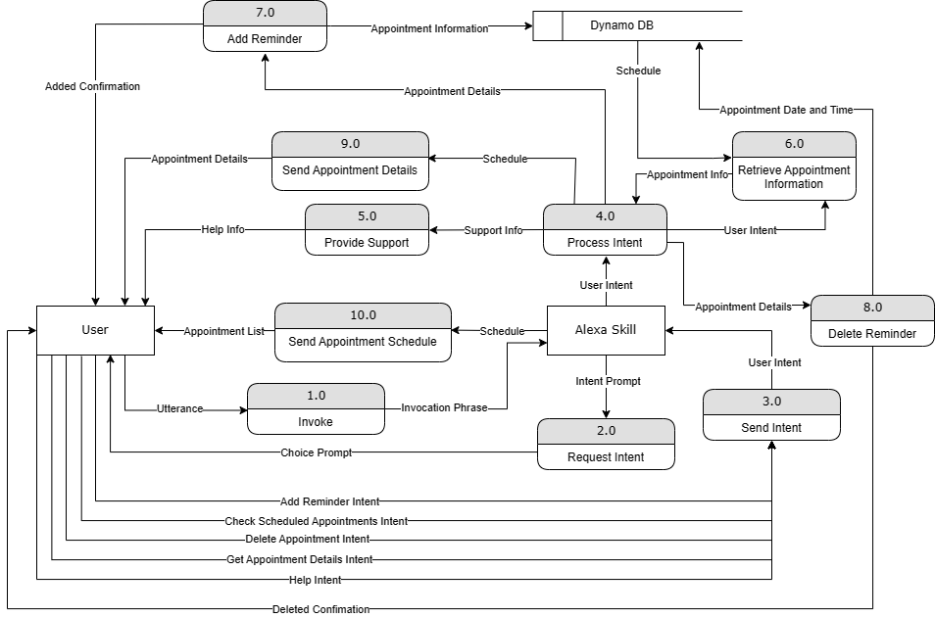

4. Level 1 Diagram

### Level 2 Diagram

5. Level 2 Diagram

## Data Definitions

**Add Reminder Intent –** The intent of the user which specifies their desire to add a new reminder to their appointment schedule.

**Added Confirmation –** Confirmation provided by Alexa that a new reminder has been added to the schedule.

**Appointment Date and Time –** The time and date of an appointment.

**Appointment Details –** Details associated with an appointment including the date, time and physiotherapist.

**Appointment Information / Info –** Information on the appointments associated with a user.

**Check Scheduled Appointments Intent** – The intent of the user which indicates their desire to check their current appointment schedule.

**Choice Prompt –** Prompt provided by Alexa to get a user to indicate their desired action.

**Delete Appointment Intent –** The intent of the user which indicates their desire to delete a specific appointment.

**Deleted Confirmation –** Confirmation that the specified appointment has been deleted.

**Deleted Notification –** An alert sent to the user indicating that the specified appointment has been deleted.

**Get Appointment Details Intent –** The intent of the user which indicates their desire to get details about a specific appointment.

**Help Info –** Information about what the skill can do.

**Intent –** The intended action as provided by the user.

**Intent Prompt –** Prompt from Alexa for the user to specify their intent.

**Invocation Phrase –** Phrase which invokes the Alexa Skill.

**Prompt –** Prompt generated by Alexa.

**Response –** Reply provided by Alexa to the user based on the processed intent.

**Schedule –** The appointment schedule associated with a user.

**Support Info –** Information provided about the skill to support the user.

**User Intent –** This is the intent provided by the user based on what action they would like to perform.

**Utterance –** Specific words and phrases spoken by the user to invoke the skill’s intent.

**Confirmed Deletion Choice –** The appointment confirmed by the user to be deleted from their schedule.

**Confirmation Prompt –** Prompt sent to the user to confirm the intended action.

**Confirmation Response –** Response provided by the user confirming their intended action.

**Reminder Created Notification -** An alert sent to the user indicating that an appointment has been created.

**Reminder Added Notification –** Confirmation to be sent to the user indicating that the appointment has been added to their schedule.

# System Architecture

## System Components

**User Interface:** Interaction with this skill will be facilitated through voice commands and responses.

**Backend:** Responsible for processing user requests, managing the appointments and sending reminders.

**Database:** Used to store user identification and appointment records.

## Technology Stack

**Alexa Skills Kit:** The development platform for building Alexa skills, allowing developers to create voice-driven experiences.

**Amazon Web Services (AWS):** Cloud services that host the skill's backend logic and data storage.

**AWS Lambda:** Powers the backend logic and executes functions triggered by user commands.

**DynamoDB:** Database used to store and retrieve data.

**AWS Identity and Access Management (IAM):** Web service that helps securely control access to AWS resources.

# Constraints and Assumptions

## Constraints

1. **Time**: Skill must be fully developed and tested within 4 weeks.
2. **Hardware:** The skill will require an Alexa-enabled device with a working microphone and speaker. Some examples of these devices include:
   1. Alexa Echo Devices
   2. Smart Home Devices
   3. Phone/Tablet
   4. Computer
3. **Internet Connectivity:** Users will need a stable internet connection in order for the skill to function properly.
4. **Privacy & Security:** The Alexa skill should not reveal an individual’s schedule information to other users. The skill design should be privacy conscious and implement data hiding, such that:
   1. Users of skill must not be able to access the client’s or other users’ data.
   2. Client must not be able to access users’ data.
5. **Usability:** The skill should be user-friendly, keeping in mind that the users are of an older age range and need high levels of accessibility.
6. **Voice Interaction:** The skill's functionality is limited to voice interactions, which may pose constraints for users with hearing or speech impairments.

## Assumptions

1. **Data Integrity:** Data associated with patient appointments, therapist information, and appointment reminders are accurate, complete, and free from errors.
2. **Data Validity:** The skill will be able to detect invalid responses from users, ensuring that data conforms to the appropriate data types.
3. **Stable Internet Connection:** Users have access to a stable internet connection.
4. **User Access:** Users have access to an Alexa-enabled device.
5. **User Behavior:** Users are familiar with the Alexa interface.
6. **Voice Recognition:** Voice recognition and natural language processing used to interpret commands are reasonably accurate.

# Prospective Feature Set

Several features could be added to this project in the future, to enhance user experience when interacting with the skill. Some of these features include:

* **Appointment Notifications:** This solution would provide automated reminders to patients, delivered through their preferred medium. Some of these channels would include email or SMS..
* **Reminder Feedback:** This version of the system would allow patients to confirm their attendance by responding to the reminder message provided. This would enable the physiotherapists to get advanced information on the patient’s attendance.
* **Real Time Updates:** This alternative would provide real-time updates to the scheduling system used by O.P.S. staff, ensuring that changes in patients’ availability are reflected in real time.
* **Appointment Rescheduling:** Allow patients to reschedule appointments through the system, reducing the need for direct communication with the clinic.